1First create Custom Image

It might contain OS. , metadata, Data

Craete normal VM and then e will install a software in it. After its working, then we will create a Custom Image , and then using this Ciustim Image , we will install new VM.

So, it will ciontain OS an software that was installed in prev VM

Install apache 2

sudo apt-get install apache2

intemtionally do not add http rile first

then go to VM

inbound security rules > advanved > Http

Now create Custom Image from thin VM

For tgis , go to VM > Click on Capture

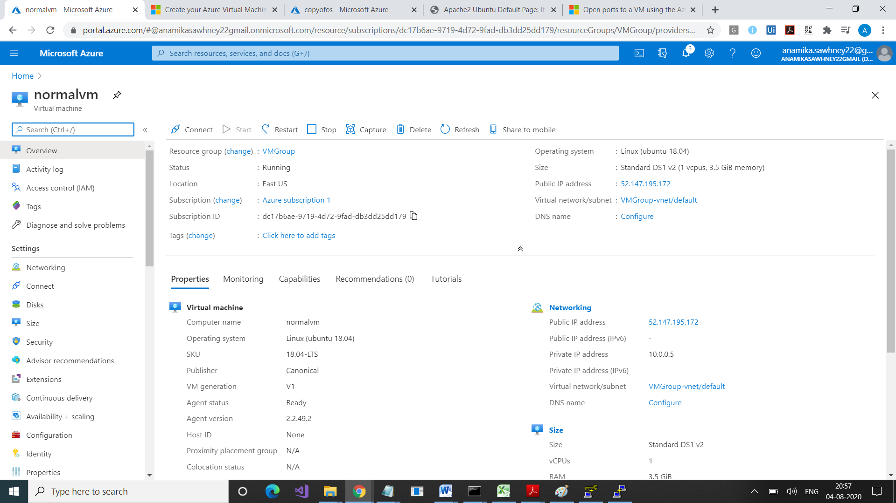

It wil take you t the following page

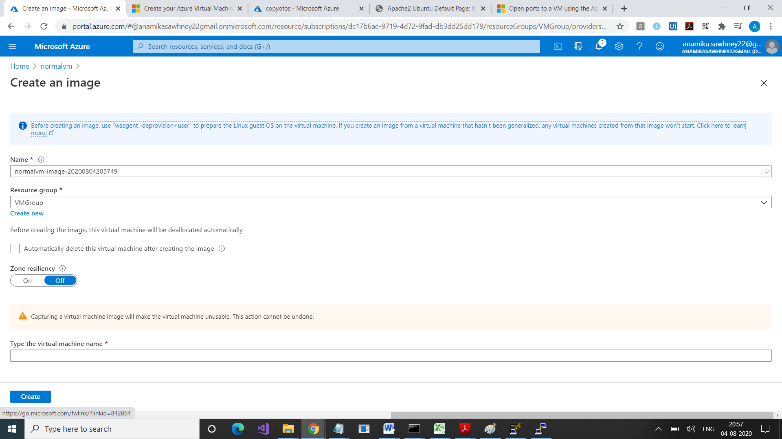

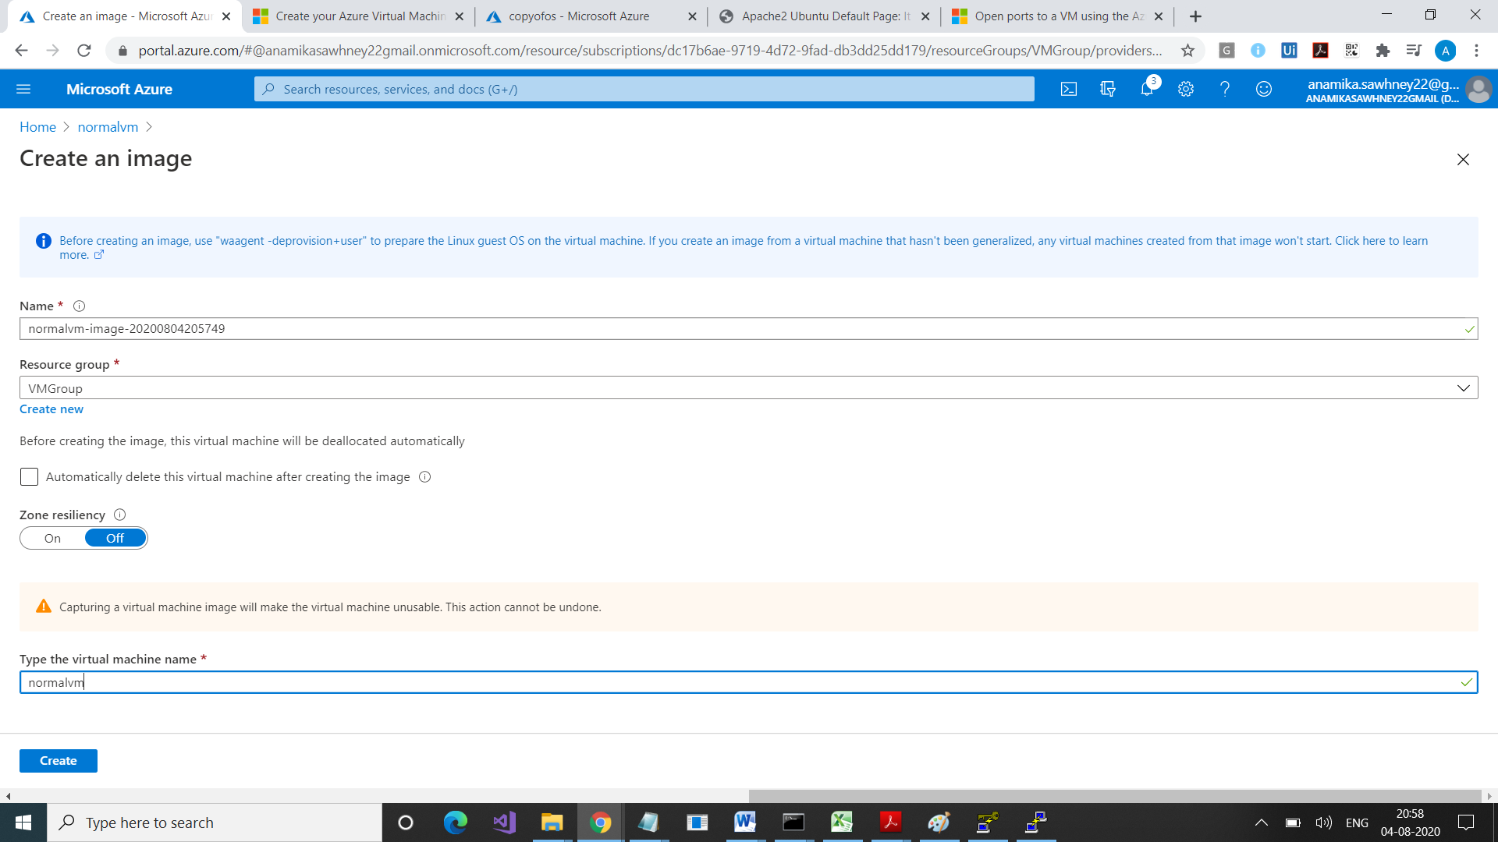

Check it in Images

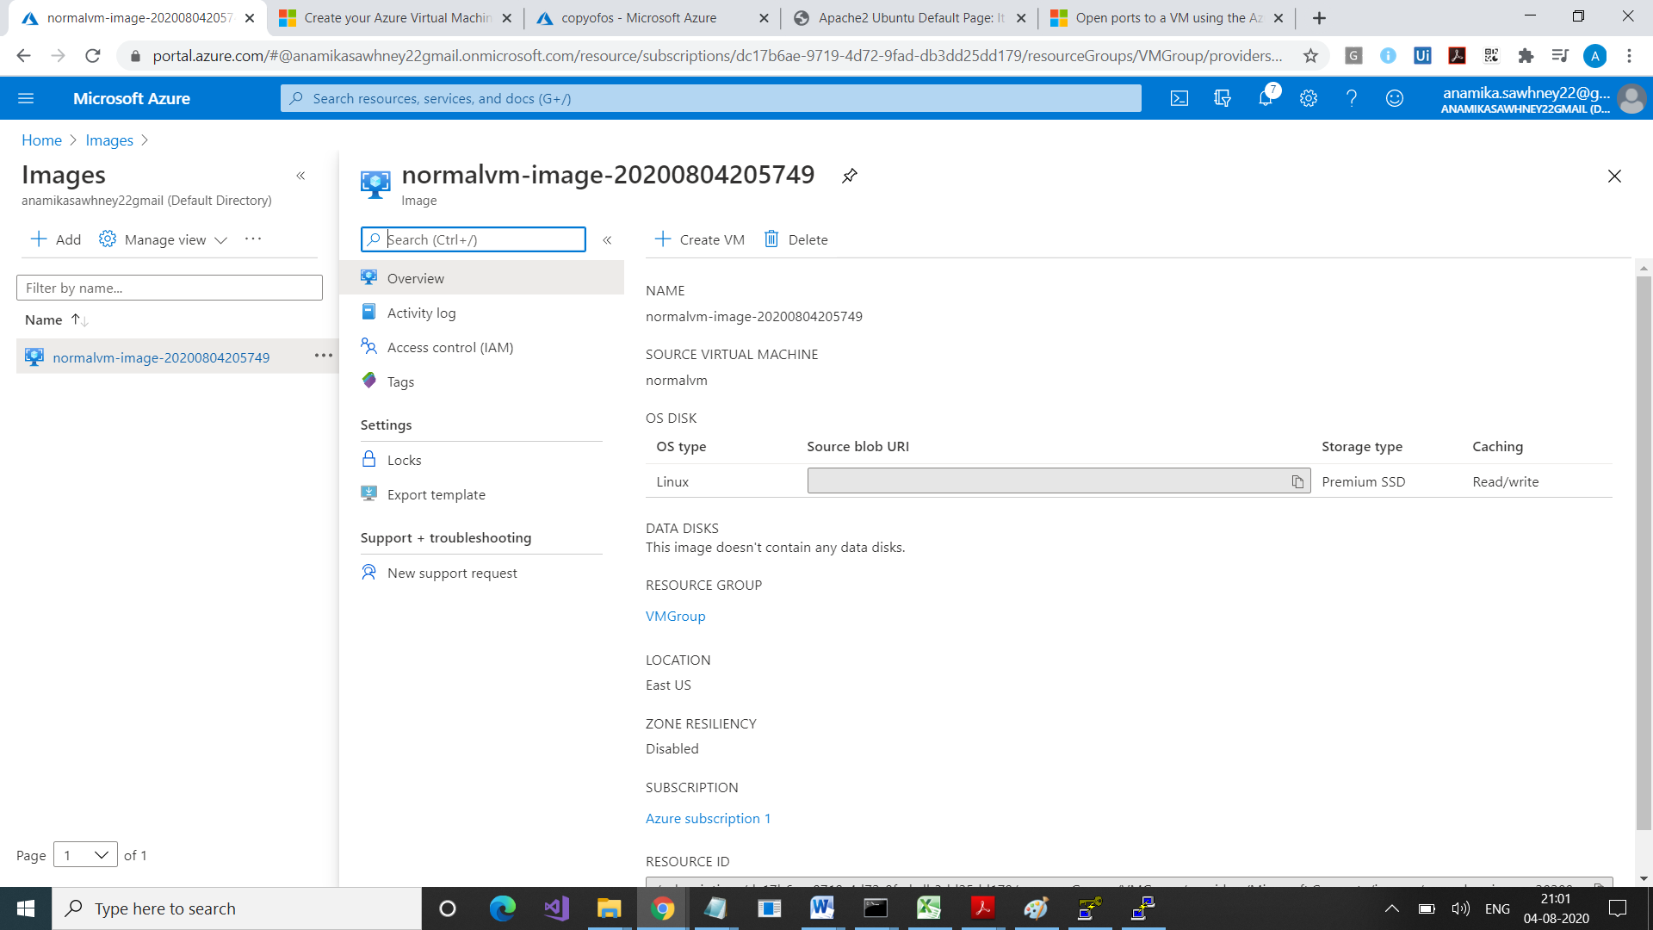

Select Create VM

Use prev private key

No need to use putty. Just go to browser and type public ip address